 | 12.3.4 Editors - Geometry Nodes Editor - Sidebar - Group tab
Table of content
Group tab - Input panel 1
Inputs 2
List 2
Drag handler 2
Search 2
Add / Remove Node Tree Interface Socket 2
Sort 2
Name 2
Default 2
Min 2
Max 2
Hide Value 2
Group tab - Output panel 2
Inputs / Outputs 3
List 3
Drag handler 3
Search 3
Add Node Tree Interface Socket 3
Sort 3
Name 3
Default 3
Min 3
Max 3
Hide Value 3

Group tab - Input panel

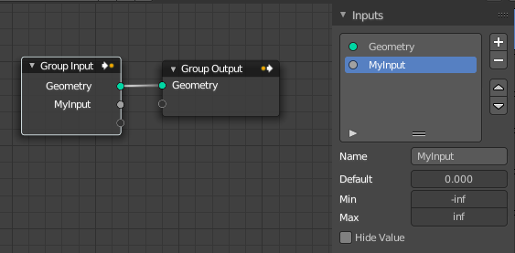
Manage the input properties of the Group Input node.

More than one input slot can be useful when you want to modify the geometry in more than one way.

Inputs

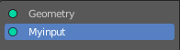
List
List of available input or output slots.

Drag handler
Resize the list.

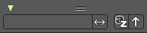
Search
Opens a search field with its options.

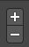
Add / Remove Node Tree Interface Socket
Adds a new input slot to the list. Or removes the selected input slot.

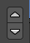
Sort
Move the selected node up or down in the list.

Name
Change the name of the current selected input slot. Type in a new name and hit enter.

Default
The default value for the input node.

Min
The minimum value for the input node.

Max
The maximum value for the input node.

Hide Value

Hide the input value even when the socket is not connected.

Group tab - Output panel

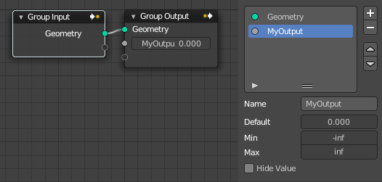
Manage the output properties of the Group Output node.
More than one input slot can be useful when you want to modify the geometry in more than one way.

Outputs

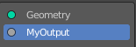
List
List of available input or output slots.

Drag handler
Resize the list.

Search
Opens a search field with its options.

Add Node Tree Interface Socket
Adds a new output slot to the list.

Sort
Move the selected node up or down in the list.

Name
Change the name of the current selected input slot. Type in a new name and hit enter.
The X button at the end will remove the selected input slot from the list.

Default
The default value for the output node.

Min
The minimum value for the input node.

Max
The maximum value for the output node.

Hide Value
Hide the input value even when the socket is not connected.

